**Kryptos Decipher**

# Typo Confounds Kryptos Sleuths

Kim Zetter Email04.20.06

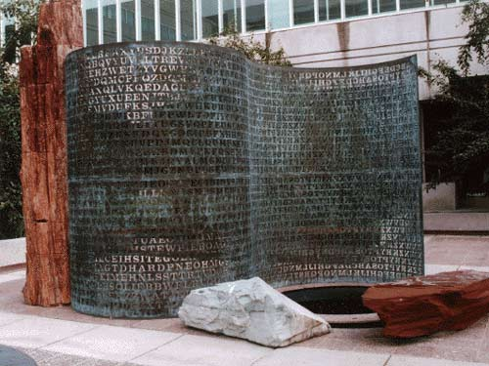

Kryptos depicts a verdigrises copper "page" scrolling out from a slab of petrified wood, like an ancient parchment scroll or computer printout. The scrambled text includes four sections, three of which have been cracked. The fourth section has resisted interpretation for 15 years.

For more than a decade, amateur and professional cryptographers have been trying to decipher an encrypted sculpture that sits on the grounds of the CIA headquarters in Langley, Virginia. Three-fourths of the sculpture has already been solved.

But now Jim Sanborn, the artist who created the Kryptos sculpture, says he made a mistake. A previously solved part of the puzzle that sleuths assumed was correct for years isn't. The new information, including what the mistaken text really says, is creating a buzz among enthusiasts who've been obsessed over the sculpture for years.

It all comes down to a letter that Sanborn left out of the sculpture. He only recently realized the omission was leading sleuths down a misguided path. His followers, however, aren't feeling any grief about the misdirection.

"Any time we get the sculptor saying anything for sure, it's cause for celebration," says Elonka Dunin, a game developer for Simutronics and co-moderator of a Yahoo group devoted to Kryptos who also maintains a comprehensive website about the sculpture. "We love to get any information out of him that we can."

Dunin, author of a new book of codes and puzzles that includes a couple of pages about the Kryptos mystery, said Sanborn called her Wednesday to announce the mistake. She says knowing the correct interpretation will help the group refocus its efforts and abandon dead ends its members have been pursuing since 1999.

Kryptos, which means "hidden" in Greek, sits outside a cafeteria on the CIA grounds and consists of a large block of petrified wood standing upright, with a copper plate scrolling out of the wood like a sheet of paper in the shape of an S. The sculpture contains approximately 1,800 letters carved out of the copper plate in four sections, some of which form an encryption table used for deciphering the rest of the sculpture.

[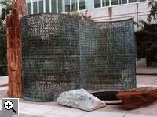](http://www.diggersrealm.com/mt/archives/20050127/kryptos.html)

In 1999, California computer scientist Jim Gillogly solved three of the four sections. A CIA analyst named David Stein reached the same solution for those sections a year earlier, but his work remained unknown to anyone outside the CIA until Gillogly came forward with his solution.

The first section of the sculpture was decrypted to a poetic phrase created by Sanborn. The second refers to something possibly buried on the CIA grounds: Does Langley know about this? They should: It's buried out there somewhere. The third section is text from archaeologist Howard Carter's diary describing the opening of a door in King Tut's tomb Nov. 26, 1922.

The fourth part has remained stubbornly unsolved. The sculpture received a lot of renewed interest last year after Wired News published a story discussing author Dan Brown's references to it in the book jacket for The Da Vinci Code. Since then, thousands of new sleuths have been obsessing over the code. Chris Hanson, co-moderator of the Yahoo group and a Colorado programmer who runs a 3-D landscape software company called 3D Nature, created a model of the CIA's building complex, complete with landscaped grounds, to study the sculpture's surroundings for clues. Another member of the group even reportedly quit his job to devote time to cracking the code.

Sanborn has said that clues to the last section, which has only 97 letters, are contained in previously deciphered parts. Therefore getting those first three sections correct is crucial.

**Decrypting The CIA Sculpture Kryptos**

In 1990 artist Jim Sanborn put together a sculpture at the CIA called *Kryptos* (which is Greek for "hidden"). The sculpture consists of four coded panels and for nearly 15 years later one of the panels still has not been decoded. From the three panels that have been decoded it seems to hint at a something hidden on the CIA grounds. Sanborn says once all four are decoded that someone must be on the grounds of the CIA to solve the riddle.

There has been no progress since 1998 on decoding the sculpture. A CIA analyst, David Stein, cracked three of the panels back then and a year later a computer scientist, Jim Gillogly, cracked the same three panels using a Pentium II. There are still amateur code breakers out there trying to decipher the code, but there has been no progress in the past 7 years. The fourth panel consists of less than 100 characters

Wired Magazine

*Sanborn may be referring to something he buried on the CIA grounds, though he's not saying. The decrypted text mentions a burial and gives latitude and longitude coordinates (38 57 6.5 N, 77 8 44 W), which Sanborn said referred to "locations of the agency." The coordinates, slightly altered, appear on the Da Vinci Code book jacket. Brown made the first number 37 instead of 38; he's said that he may reveal the reason in future books. Some sleuths have determined that the coordinates on the sculpture mark a spot on the CIA grounds about 150 feet from the sculpture. Others have placed it elsewhere, however.*

*...*

*The first section is a poetic phrase, which Sanborn composed himself. The second hints at something buried: "Does Langley know about this? They should: It's buried out there somewhere." The third section comes from archaeologist Howard Carter's diary describing the opening of a door in King Tut's tomb on Nov. 26, 1922.*

*...*

*Until now, only three people were said to know the solution to Kryptos. Sanborn, a CIA cryptographer named Ed Scheidt who helped him choose and alter the coding techniques for the sculpture, and former CIA director William Webster, who received a sealed envelope containing the solution, which sits in a CIA archive until the time when someone solves the puzzle.*

*But Sanborn told Wired News that Scheidt, now a retired chairman of the CIA's Cryptographic Center, and Webster only think they know the solution.*